

Lockdown and Critical Incident Management Arrangements for Gwenfo Church in Wales Primary School

May 2024
Discussed with all staff – due to be ratified Oct 24

Subject |  | Page
1.0 | Introduction | 3
2.0 | Creating Lockdown Procedures for Schools | 4
3.0 | Partial Lockdown Procedures | 5
4.0 | Full Lockdown Procedures | 6
5.0 | Communication | 7
6.0 | Training | 8

Introduction

Lockdown is the ability to quickly restrict access and egress to a school site or building (or part of) through physical measures in response to a threat, either external or internal.

The aim is to either prevent pupils, staff or visitors from moving into areas of danger or preventing/frustrating an attacker from accessing a site (or part of). Due to their nature, some school sites may not be able to physically achieve lockdown.

Lockdown procedures should be seen as a sensible and proportionate response to any external or internal incident which has the potential to pose a threat to the safety of staff and pupils.

Procedures should aim to minimise disruption whilst ensuring the safety of all pupils, staff and visitors.

Examples of situations that may trigger a full or partial lockdown include:

- A reported incident/civil disturbance in the local community (with the potential to pose a risk to staff and pupils in the school).
- An intruder on the school site (with the potential to pose a risk to staff and pupils).
- An intruder in the school (with the potential to pose a risk to staff and pupils).
- A warning being received regarding a risk locally, of air pollution (smoke plume, gas cloud etc.) or chemical, biological or radiological contaminants.
- A major fire in the vicinity of the school.
- Extreme weather conditions e.g. Met Office Red “Risk to Life” warning issued
- Instruction issued by the police or other emergency services

In addition to this guidance schools should read and consider the Stay Safe principles published by the National Counter Terrorism Policing (NaCTSO) that details the actions that should take in the event of a fire arms or weapons attack

Annex A contains information on Stay Safe requirements

Creating Lockdown Procedures for Schools
All schools should consider the need for an effective and tested lockdown procedures. Schools should consider two types of lockdown; ‘partial’ and ‘full’. These arrangements should be determined by schools on an individual basis, as they will be dependent to a large extent on local circumstances such as premises design and layout, class arrangements, resources available, etc.
Each school must develop its own specific guidance document. The following general principles should be included in the plan:

- A senior member of staff is nominated as Lockdown Manager (LM) (plus deputies in their absence) to initiate, manage and conclude the lockdown. In the case of Gwenfo Church in Wales Primary , the LM will be Headteacher Nicola Starke and subsequently Samuel Bean in her absence.
For the remainder of this document, Lockdown Manager will be Nicola Starke and ALM will be Samuel Bean
- A recognised signal, audible throughout the school is used to alert staff to the activation of the plan. This signal should only be used for this purpose and will be 3 blasts of a whistle
- The creation of a checklist of the actions to be taken in the event of a partial or full lockdown
- Ability of pupils to understand and respond appropriately to alarms/commands
- The use of the fire alarm will be avoided to reduce the incorrect response to an incident.
- Pupils/staff who are outside of the school buildings should be brought inside as quickly as possible.
- Those inside the school should remain in their classrooms or proceed directly to the nearest classroom.
- All external doors and, as necessary, windows are locked (depending on the circumstances, internal classroom doors may also need to be locked where possible).
- Blinds/curtains drawn and windows on internal doors covered.
- Once in lockdown mode, staff should notify the LM immediately of any pupils not accounted for and any additional pupils/staff in their classroom via the agreed communication channel. This will be via internal phone to 107
- The school should establish communication with the Emergency Services as soon as possible.
- Vale of Glamorgan (LA) should be notified as soon as practical via Department of Director of Education & Inclusion Services – pham@valeofglamorgan.gov.uk
- If it is necessary to evacuate the building, the fire alarm should sound.
- The school should arrange suitable alternative accommodation for pupils and staff in the event of the school being evacuated. In the first instance this would be the Village Hall
- Ensure procedures are in place for members of staff who do not have a regular office or classroom.
- Ensure catering, cleaning, breakfast club staff are included in your school lockdown plan.
- Establish an official lockdown termination announcement/signal so that all staff know that it is authentic, that is only used for this purpose. This will be via a member of SLT visiting classrooms to alert the lockdown has terminated.
- Specific arrangements should be made for pupils/staff with different needs (i.e. hearing/visual impairment or mobility needs).
- Areas in the school that cannot be effectively locked down should be identified and the lockdown procedures should include instructions on removing staff and pupils from these areas to an alternative place of safety (i.e. toilets/outbuildings).
- Geographical location – urban/rural when considering likely response time of emergency services
- Identifying alternative accommodation for staff and pupils in the event the school has to be evacuated.

Partial Lockdown

  - Alert to staff: ‘Partial lockdown’

This may be as a result of a reported incident / civil disturbance in the local community with the potential to pose a risk to staff and pupils in the school. It may also be as a result of a warning being received regarding the risk of air pollution, etc.

Staff and pupils should remain in the school building and all doors leading outside should be locked and windows secured. No one should be allowed to enter or leave the building; however teaching and work can continue as usual. Schools should make an informed decision as to whether pupils should remain in class rooms or be allowed to travel around the school. Staff and pupils engaged in outdoor activities should be called back into school.

A ‘partial lockdown’ may also be a precautionary measure that puts the school in a state of readiness (whilst retaining a degree of normality) should the situation escalate.

All situations are different. Once all staff and pupils are safely inside, the LM and senior staff will conduct an ongoing and dynamic risk assessment based on advice from the Emergency Services.

Partial Lockdown - Immediate action

The school is alerted to the activation of the plan by a recognised signal (3 blasts on a whistle), audible throughout the school that is only used for this purpose

Emergency services notified via LM

Vale of Glamorgan County Council (LA) should be notified as soon as practical via Director of Learning and Skills – tel no. 01446 709161

All outside activity to cease immediately, pupils and staff return to building. (There needs to be a means of communicating the alert to duty staff at break times, sports lessons etc.)

All staff and pupils remain in building and external doors and windows locked

Free movement may be permitted within the building dependent upon circumstances

In the event of an air pollution issue, air vents, fans, heating and air conditioning systems should be closed or turned off

Use anything to hand to seal up all cracks around doors and any vents into the room – you aim to minimise possible ingress of pollutants

Staff should await further instructions from the Emergency Services who will advise on the best course of action in respect of the prevailing threat. Pupils must not be released to parents during a lockdown unless authorised by LM or emergency services.

Staff and pupils should remain in partial lockdown lock down until it has been lifted by school’s LM/ALM or the emergency services.

If at any point during the lockdown there is a requirement to evacuate the school, this should be activated by the fire alarm. It should not be used to raise the initial alarm as it may trigger an evacuation that could lead pupils and staff to the source of danger.

Full Lockdown

  - Alert to staff: ‘Full lockdown’

This signifies an immediate threat to the school and may be an escalation of a partial lockdown. The aim of a full lockdown is for all pupils, staff and visitors to be located in a place of safety and the school and its rooms to appear empty.

In the event of a firearms or weapons attack, the Stay Safe guidance at annex A should be followed.

The fire alarm should not be used to raise the initial alarm as it may trigger an evacuation that could lead pupils and staff to the source of danger (3 blasts of a whistle is the signal)

Schools should use the following procedures to develop their own arrangements:

Immediate action

The school is alerted to the activation of the plan by a recognised signal (3 blasts on a whistle), audible throughout the school that is only used for this purpose

Emergency services notified via LM

Vale of Glamorgan County Council (LA) should be notified as soon as practical via Director of Learning and Skills – tel no. 01446 709161

All outside activity to cease immediately, pupils and staff return to building. (There needs to be a means of communicating the alert to duty staff at break times, sports lessons etc.)

All staff and pupils/staff kept in their classroom or moved to the nearest designated safe place

Non-teaching staff (administrative, catering, cleaners) should remain in their workplace.

External doors locked. Classroom doors locked (where a member of staff with key is present) or barricaded with available classroom furniture if doors cannot be locked

Windows locked, blinds drawn, windows covered if possible (so an intruder cannot see in)

Pupils/staff sit quietly out of sight and where possible in a location that would protect them from gunfire (consider locations behind substantial brickwork or heavy reinforced walls)

Lights, smartboards and computer monitors should be turned off

Mobile phones turned off or turned onto silent mode so they cannot give away your position

A register to be taken of all pupils/staff in each classroom/office

Communicate register of pupils/staff to a pre-agreed central office (Headteachers office Phone 107) including the details of other pupils or staff in the classroom

Staff should await further instructions from the Emergency Services who will advise on the best course of action in respect of the prevailing threat.

Staff and pupils should remain in lockdown until it has been lifted by school’s LM/ALM or the emergency services. Pupils must not be released to parents unless authorised by LM or emergency services.

If at any point during the lockdown there is a requirement to evacuate the school, this should be activated by the fire alarm. It should not be used to raise the initial alarm as it may trigger an evacuation that could lead pupils and staff to the source of danger.

Communication

  - Internal Communication

During the lockdown, staff will keep agreed lines of communication open, but should not make unnecessary calls to the central office as this could delay more important communication.

Examples of discreet communication channels might be:

    - Where staff have access to an internal e-mail system, they could access their account and await further instruction. In practical terms, staff would need to be familiar with accessing their account through a variety of means e.g. laptop, smartphone or tablet.
    - Where a school uses ‘Parentmail’ or other systems, then staff could be put into a defined user group. This could then be used to communicate instructions via text message in an emergency.
    - Staff should avoid using the internal telephone system as this should be kept clear for communication with emergency services

External Communication

It should be anticipated that in the event of a lockdown a large number of calls will be made both to the school and Local Authority with requests for information and updates.

During the lockdown, only the LM should communicate details of the threat to the emergency services and the Local Authority. This will avoid duplication and contradictory information.

Communication with parents’ will need to reassure parents that the school understands their concern for their children’s welfare and that everything that can possibly be done to ensure children’s safety will be done. It may be useful for schools to develop a pre-recorded voice message to inform callers that the school is in lockdown and request that parents do not come to the school as pupils will not be released until the emergency services have declared the lockdown over. This message should also contain the details of numbers that parents and others should call for information and updates.

The Local Authority via the Media Team should provide parents, the press and others with timely and accurate information until the lockdown and subsequent debrief is completed.

Planning should also consider whether other means of communication including social media are appropriate at this time. The Media manager should be consulted for advice and guidance.

Emergency Services

It is important to keep lines of communication open with Emergency Services as they are best placed to offer advice as a situation unfolds. The school site may or may not be cordoned off by Emergency Services depending on the severity of the incident that has triggered the lockdown.

In the event of a prolonged lockdown or more severe scenario, emergency services, local authorities and voluntary sector organisations will work together to co-ordinate practical and emotional support to those affected by any emergency, also referred to as humanitarian assistance. A reception centre for friends and family could be set-up outside of the cordoned area.

Training

Due to the fast moving nature of incidents that could trigger a lockdown, it is important that all staff are able to act quickly and effectively to protect themselves, pupils and visitors.

Staff should have a clear understanding of their roles and responsibilities in a lockdown situation and fully understand the procedures adopted by the school. In particular those with key functions including:

  - Lockdown Manager and Assistant Lockdown Manager
  - Senior management team
  - Administration staff
  - Teaching and non-teaching classroom staff
  - Site managers/caretakers

As appropriate for their age and cognitive ability, pupils should also be made aware of the plan, regular practices will increase their familiarity.

Staff’s understanding should be checked with regular training refreshers. A lockdown drill should be undertaken at least once a year and thoroughly debriefed to monitor the effectiveness of your arrangements. This could be done as a walkthrough with staff if appropriate.

Parents should be informed that the school has a lockdown plan and that it will be regularly tested. However for obvious reasons it is not advisable to share the school’s full lockdown plan.

It would also be good practice to:

  - Conduct a number of table top exercises with the senior leadership team to test the procedures against various scenarios.
  - Rehearse lockdown arrangements with all staff and pupils.
  - Display lockdown drill information in staff rooms, every classroom alongside information relating to fire drills.
  - Establish agreed methods of communication from staff to the lockdown manager should a dangerous intruder be located on the school premises.
  - An overview sheet outlining the school’s procedures will be displayed in the staffroom and other places throughout the school as appropriate (see Appendix B).

Post Incident

The LM should arrange a debrief for staff, pupils, parents, LA and others as soon after the incident as is reasonable.

The aim of the debrief is to measure the effectiveness of the way the lockdown was initiated and carried out. It will identify any weaknesses or gaps in the effectiveness of the school’s planning and operation and also what worked well.

These should be recorded and the schools procedures amended as appropriate.

Conclusion

No guidance will ever cover every eventualities, but with effective planning and communication, everyone will be as prepared as possible should a lockdown situation ever arise. Though unavoidable, the more preparation that has taken place, the greater the chance there will be less panic and confusion, enabling staff to protect the children in their care to the best of their ability.

Appendix A

NaTSCO Stay Safe - Firearms and weapons attack

‘Stay Safe’ principles (Run Hide Tell) give some simple actions to consider at an incident and the information that armed officers may need in the event of a firearms and weapons attack.

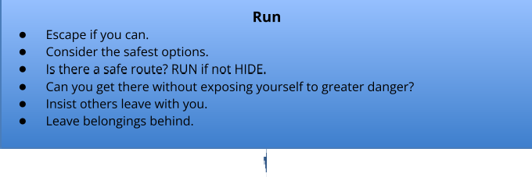
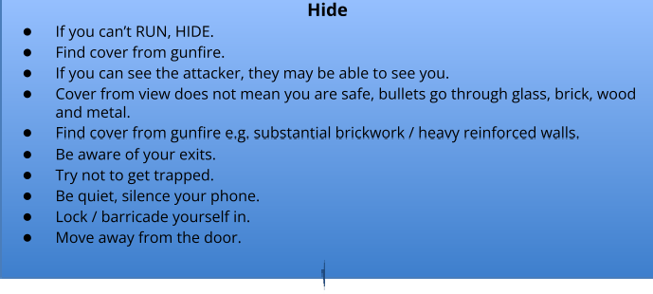
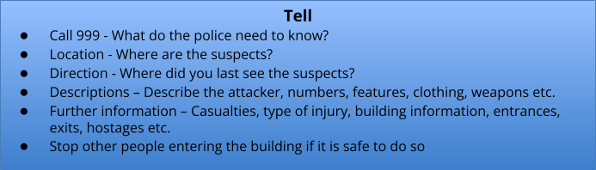
Full guidance is contained on the NaCTSO website: https://www.gov.uk/government/publications/recognising-the-terrorist-threat

Armed Police Response

- Follow officers’ instructions.
- Remain calm.
- Can you move to a safer area?
- Avoid sudden movements that may be considered a threat.
- Keep your hands in view.

Officers may

- Point guns at you.
- Treat you firmly.
- Question you.
- Be unable to distinguish you from the attacker.
- Officers will evacuate you when it is safe to do so.

You must STAY SAFE

- What are your plans if there were an incident?
- What are the local plans?

.

Appendix B - Lockdown Flow Chart

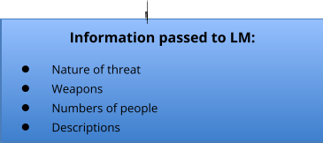
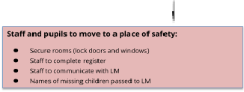
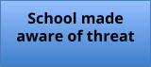


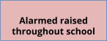
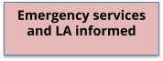
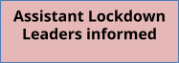
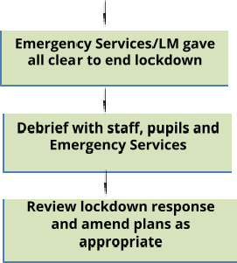
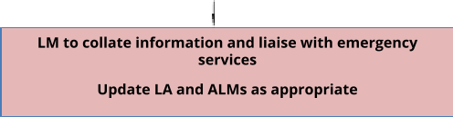

Action | Contact Details | Remarks | Action completed
Inform Assistant Lockdown Manager(s) and reception of requirement to lockdown school | 100 Receptio  107 Head’s Office | Mobile phone. Personal numbers shared
Initiate lockdown procedure | NS and SB to meet in designated area depending on where risk takes place | Head teacher’s office
Contact emergency services | 999 | Request police and provide the following details:  - Nature of emergency  - Name of school  - Address and postcode  - Contact details (name and phone number)  - Other details as required
Contact LA’s Education & Inclusion Services’ Senior Management Team who will liaise with school and other agencies | 01446 709161 | Provide the senior manager with the following information:  - Nature of emergency  - Name of school  - Address and postcode  - Contact details (name and phone number)  - Other details as required
Confirm lockdown is in place throughout school | 3 short sharp bursts | Senior team to check doors

Appendix C - Initial Emergency Procedures in the Event of a School Lockdown
15

16

