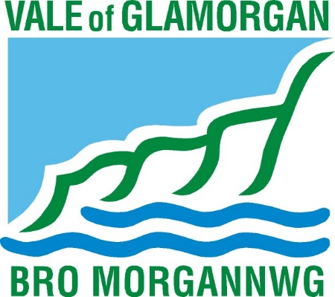
Appendix A

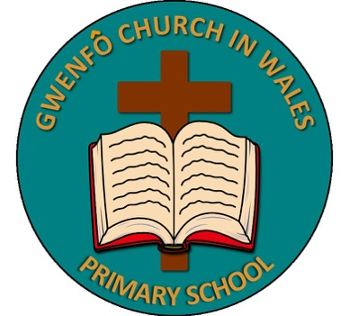

Working together for a fairer future
Gwenfo Church in Wales Primary School Strategic Equality Plan 2022 – 2024

You can ask for this document in other formats,
for example: a larger font; on different colour paper

You can ask for this document in Welsh.

Working together for a fairer future
Gwenfo Church in Wales
Strategic Equality Plan 2022 – 2024

Contents 1
Introduction 2
Purpose of the Strategic Equality Plan 4
Vision and values 5
Equality objectives – what we will do 7
Monitoring Progress and Publishing Results 11
For More Information 11

Introduction

Gwenfo is a Voluntary Controlled (VC) Church in Wales Primary School and falls under The Llandaff Diocesan Council for Education. The maintaining Local Authority is The Vale of Glamorgan Council. Gwenfo is in the village of Wenvoe in the Vale of Glamorgan. It serves its community by working in partnership to provide an education of the highest quality within the context of Christian belief and practice, and an understanding of shared values.
It is with a great deal of pride that we are introducing the School’s Strategic Equality Plan for 2022 – 2024 – ‘Working together for a fairer future’. Equalities is best taught in the context of UK law, where all protected characteristics of the Equality Act 2010 are included in a curriculum that accepts difference. So not only people of different sexual orientations are welcome in our school, people of different ethnicities, genders, gender identities, religions, ages and abilities are also most welcome.
Schools play an important role in ensuring an education for every child and young person, considering a range of needs. Schools support the well-being in their pupils and develop an ethos where learners feel everyone is included. This Plan sets out the equality agenda for our school for the next two years. We must consider how our actions and decisions will affect future generations.
Under the Equality Act 2010, schools demonstrate how they are tackling homophobic bullying, teaching about different families and promoting positive values to create global citizens. Schools must deliver a curriculum that enables learners to understand the benefits that exist in society where diversity and difference is accepted. All schools aim to support the well-being in their pupils and developing an ethos where learners feel everyone is included will support this.
It is only by working together, listening and respecting each other that we can successfully meet the many challenges facing our communities and public services today. To achieve this Plan and to meet the diverse needs of our communities, we will need to work in partnership.
We need to think about what and how we deliver educational provision. We must consider the diverse needs of our school population whether that be due to their protected characteristics and/ or their financial circumstances.
We are an ambitious and forward-thinking school. I am confident that pupils, parents. carers, staff, our Governing Body, the community and all those with a stake in our school can continue ‘working together for a fairer future’. All people, regardless of race, religion, sex, gender assignment, sexual orientation, age must feel welcome in our school, with our clear ethos that spells out acceptance.

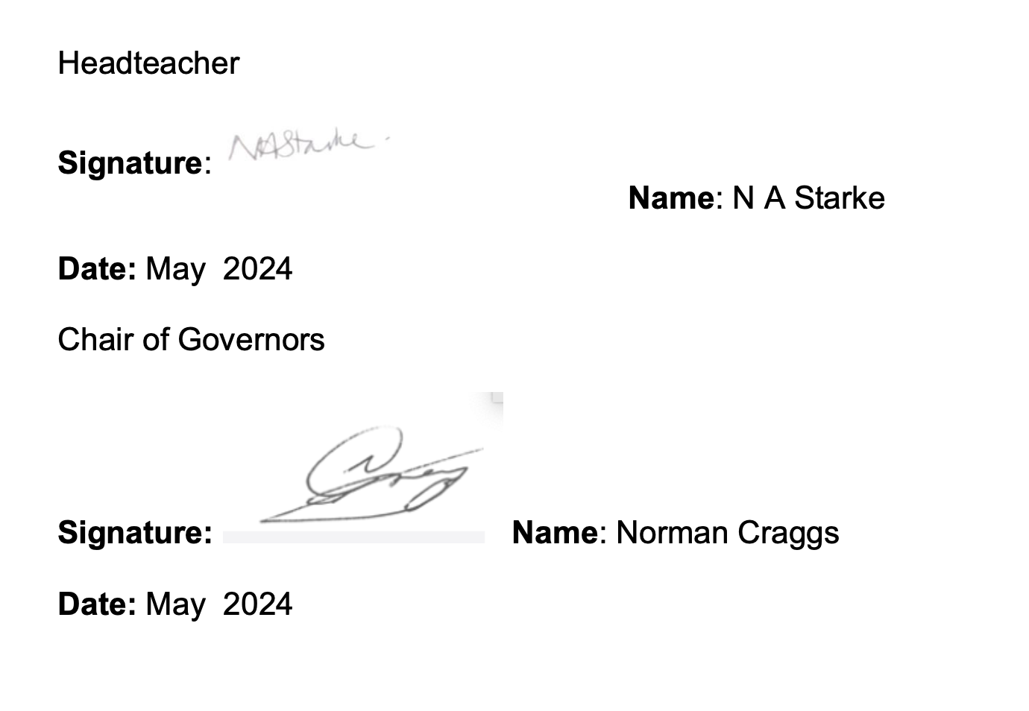  Na me Norman Craggs | Name Nicola Starke
Chair of Governing Body | Headteacher

Purpose of the Strategic Equality Plan
The Equality Act 2010 makes it clear that discrimination is not to be tolerated in society. The purpose of this Strategic Equality Plan is to describe what the school is doing to fulfil our duties under the Equality Act 2010, including the public sector Equality Duty (the’ general duty’) and the specific duties for Wales.
The public sector equality duty covers eight protected characteristics:
Age | Race
Disability | Religion or Belief
Gender Reassignment | Sex
Pregnancy and Maternity | Sexual Orientation
The duty applies to marriage and civil partnership, but only for having due regard to the need to eliminate discrimination. The Equality Act lists schools as public authorities with certain duties. This means that when we carry out our public function, we must have due regard to the need to:
- eliminate unlawful discrimination, harassment and victimisation and other conduct that is prohibited by the Act
- advance equality of opportunity between people who share a relevant protected characteristic and those who do not
- foster good relations between people who share a relevant protected characteristic and those who do not.

Having due regard for advancing equality involves:
- removing or minimising disadvantages experienced by people due to their protected characteristics
- taking steps to meet the needs of people from protected groups where these are different from the needs of other people
- encouraging people with protected characteristics to participate in public life or in other activities where their participation is disproportionately low.

To identify the priorities, we work in partnership with:
- Pupils
- School Council
- Parents and carers
- Headteachers of schools in the Vale of Glamorgan
- Governing Body
- Local Authority and Regional Consortia
We plan to use this information to help us improve the way we provide educational services and employ people.
Our School’s Strategic Equality Plan 202X–202X has been written to integrate with the Council’s Corporate Plan 2020-2025 and Corporate Strategic Equality Plan 2020 – 2024. The Corporate Plan sets out the Council’s vision for the Vale of Glamorgan, its values and main priorities. The priorities of the Corporate Plan will help make communities in the Vale of Glamorgan more equal. The equality objectives in the Corporate Strategic Equality Plan will support this work and it is for this reason that the objectives of both plans have been aligned. Our own Strategic Equality Plan aligns with these documents where relevant and appropriate.

Vision and values
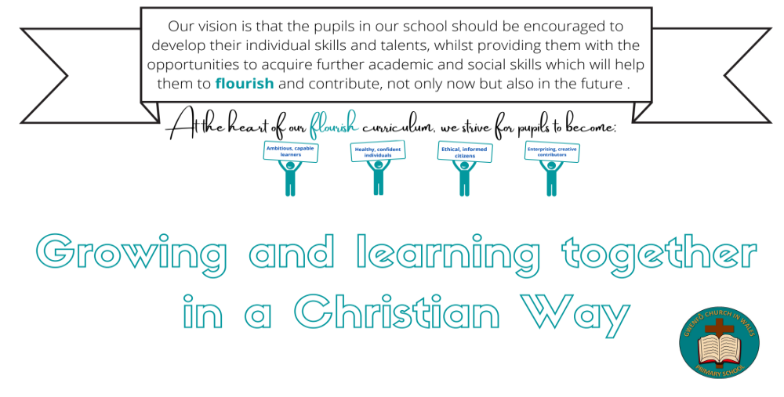

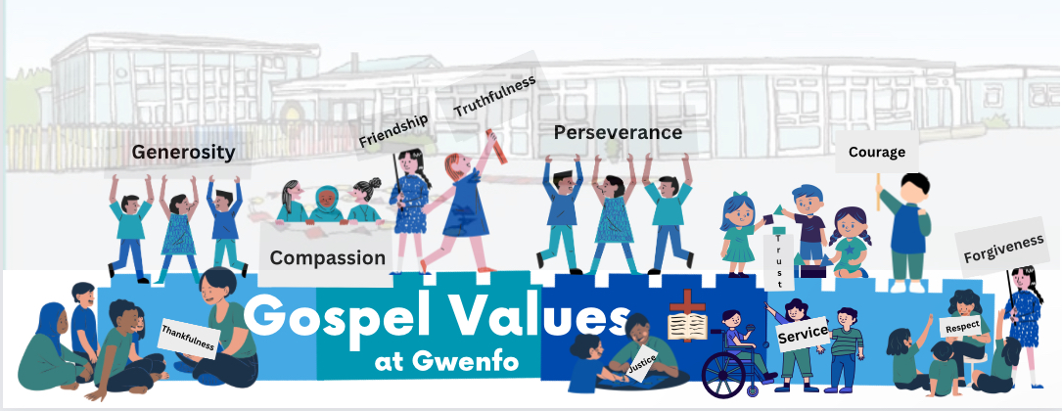

Our values are consistent with the five ways of working central to the Well-being of Future Generations Act. They are long term, they work together, and involve working with others. Our values will support a greater focus on prevention as we work to deliver our vision. Our equality priorities consider the Wellbeing of Future Generations Act and will help us to contribute to the Welsh Government’s well-being goals, including creating a more equal Wales. Equality objectives – what we will do
Strategic Equality Objective
- Improve how we involve, engage, and communicate with protected groups about our work and decisions.
Protected characteristics
This benefits all protected groups, but we will focus on disabled, people from ethnic minorities, women and those who are socio-economically disadvantaged.
Expected outcomes
Stakeholders have information about the improvements and the opportunity for input to support progress.
Actions
As a school we will:
- Promote and facilitate termly school council meetings.
- Take steps to ensure that school council is representative of the school’s learners across protected characteristics.
- Use an innovative range of ‘pupil voice groups’ which focus on shared rights and responsibilities.
- Ensure communications to parents and carers are delivered in plain, easy to understand language.
- Progress against actions identified within the school’s accessibility strategy will be included within this strategy’s annual report.
- Ensure our staff and the Governing Body receive equality and diversity training, which will include Equality Impact Assessment training and awareness.
How we will know how we are doing
- Information and data on how engagement has been used to improve outcomes for protected groups and socio-economic disadvantaged groups.
- Information and data on the number of school staff who have received equality, race, and disability training.

Strategic Equality Objective

Develop and implement plans throughout the life of this plan to address attainment gaps for children and young people and provide support to overcome barriers to them reaching their full potential.
Protected characteristics

This benefits all protected groups.

‘Is Wales Fairer 2018’ reports that attainment gaps persist for pupils in receipt of free school meals and children with additional learning needs. (Education)

Is Wales Fairer 2018’ reports that young women and girls, lesbian, gay, bisexual and transgender children and children with additional learning needs are more likely to be at risk of experiencing identity-based bullying. (Education)

Is Wales Fairer 2018’ reports that poorer children, children with additional learning needs, White children and children of mixed ethnicity have higher than average exclusion rates. (Education)

Is Wales Fairer 2018’ reports that subject choices remain highly gendered, with girls being much less likely to continue studying science and mathematics after school. (Education)
Expected outcomes

Reduction in attainment gaps.

Programmes in place to tackle identity-based bullying.

Reduced exclusion rates for children with certain protected characteristics, including disabled children and mixed ethnicity children.
Actions
As a school we will:
- Deliver and evaluate programmes and interventions aimed at addressing attainment gaps to make sure they have a positive impact on socio-economic disadvantage, disability, sex, race, other protected characteristics and young carers.
- Seek to minimise exclusion rates for children with certain protected characteristics, including socio-economic disadvantage, ethnicity and disability.
- Analyse bullying data gathered by schools, including racist bullying, to identify trends and review anti-bullying strategies so that there are effective solutions in place.
- Provide opportunities to explore equality, diversity and community cohesion within a curriculum throughout the year e.g. equality related stimuli, using texts which explore both historical and present day local, national, and international equality, diversity and community cohesion.
- Use inclusive resources which are actively inclusive, including anti-racist and promote multilingual resources, such as ‘Giglets’.
- Work with partners to deliver programmes which support people to prepare for employment.
How we will know how we are doing

- Information and data on how programmes and interventions have affected attainment gaps on children and young people with protected characteristics and who are socio-economically disadvantaged.
- Information and data on number of children excluded by protected characteristic and socio-economic disadvantage.
- Analysis of school bullying data showing trends and review of anti-bullying strategies to address findings.
- Information and data on outcomes of programmes supporting people to prepare for employment.

Monitoring Progress & Publishing Results

Our School will continue to check on progress towards meeting our equality objectives and report on this each year to the Governing Body in our annual equality monitoring report. This is published on our website and includes an assessment of the effectiveness of the steps we are taking to meet the equality objectives.

This may be complemented by other equality and employment information each year that is published annually.

For More Information

Visit our website
Please see our school website: www.gwenfoprimary.co.uk
Social Media
Keep up to date with all the latest news, events and information from our School, follow:
@School on Twitter or Facebook.
If you have a query, please contact us:
- Email gwenfops@valeofglamorgan.gov.uk
- Phone: 02920 593225

